- What is the name of the process which takes place in living cells in your body and which releases energy from oxygen and glucose?
1

.....................................................................................................................................

(1)

- Name the two products of the process in part (i).

............................................................... and ..............................................................

(1)

(Total 2 marks)

- Yeast cells can respire anaerobically.
2

The equation for anaerobic respiration in yeast is:

glucose alcohol + carbon dioxide (+ energy)

Give one way in which anaerobic respiration in yeast cells is different from anaerobic respiration in human muscle cells.

........................................................................................................................

........................................................................................................................

(1)

- Yeast can use other types of sugar instead of glucose.
Some scientists investigated the effect of three different types of sugar on the rate of anaerobic respiration in yeast.

The scientists:

  - used the apparatus shown in Diagram 1 with glucose sugar

  - kept the apparatus at 20 °C

  - repeated the investigation with fructose sugar and then with mannose sugar

  - repeated the investigation with water instead of the sugar solution.

Diagram 1
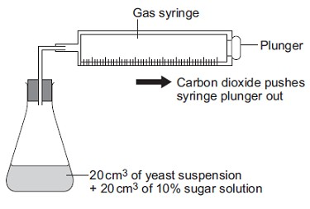

- Give two control variables the scientists used in this investigation.

...............................................................................................................

...............................................................................................................

(2)

- The graph shows the scientists’ results.
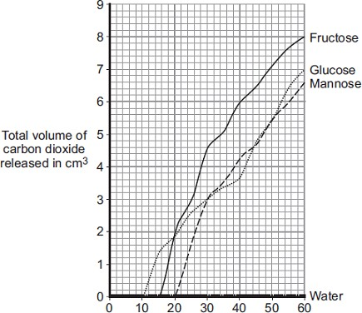
Time in minutes

From this information, a company decided to use fructose to produce alcohol and not
mannose or glucose.

Explain the reason for the company’s choice.

...............................................................................................................

...............................................................................................................

...............................................................................................................

...............................................................................................................

(2)
(Total 5 marks)

Catalase is an enzyme found in many different tissues in plants and animals.It speeds up the rate of the following reaction.
3
hydrogen peroxide water + oxygen
Figure 1 shows a 25-day-old broad bean seedling.
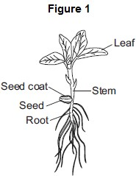

Some students investigated whether different parts of bean seedlings contained different amounts of catalase.

The students:
  - put hydrogen peroxide into five test tubes

  - added a different part of a bean seedling to each tube

  - recorded the results after half a minute.

If there was catalase in part of the seedling, oxygen gas was given off. When oxygen gas is given off, foam is produced in the tubes.

Figure 2 shows the results.
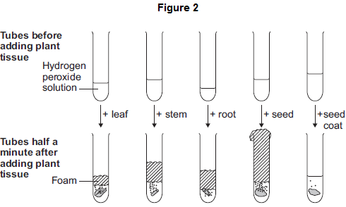

The students made the following conclusions:
- most parts of a bean seedling contain catalase

- the seed contains a lot of catalase

- stems and roots have quite a lot of catalase

- the leaves have a little bit of catalase

- the seed coat has hardly any catalase.

The students’ teacher said that the students needed to improve their investigation in order to make valid conclusions.

In this question you will be assessed on using good English, organising information clearly and using specialist terms where appropriate.

Describe how you would carry out an investigation to compare the amounts of catalase in different parts of bean seedlings.

You should include details of how you would make sure your results give a valid comparison of the amounts of catalase.

........................................................................................................................

........................................................................................................................

........................................................................................................................

........................................................................................................................

........................................................................................................................

........................................................................................................................

........................................................................................................................

........................................................................................................................

........................................................................................................................

........................................................................................................................

(6)

- Scientists investigated the effect of pH on the activity of the enzyme catalase in a fungus.

The table below shows the scientists’ results.

pH | Enzyme activity in arbitrary units
 | Test 1 | Test 2 | Test 3 | Test 4 | Test 5 | Mean
3.0 | 0 | 0 | 0 | 0 | 0 | 0
4.0 | 6 | 5 | 8 | 4 | 7 | 6
5.0 | 38 | 65 | 41 | 42 | 39
5.5 | 80 | 86 | 82 | 84 | 88 | 84
6.0 | 100 | 99 | 96 | 103 | 102 | 100
6.5 | 94 | 92 | 90 | 93 | 91 | 92
7.0 | 61 | 63 | 61 | 62 | 63 | 62
8.0 | 22 | 22 | 21 | 24 | 21 | 22

  - Calculate the mean enzyme activity at pH 5.0.

...............................................................................................................

...............................................................................................................

Mean = ......................... arbitrary units

(2)

  - On the graph paper in Figure 3, draw a graph to show the scientists’ results.

Remember to:
    - add a label to the vertical axis

    - plot the mean values of enzyme activity

    - draw a line of best fit.

Figure 3
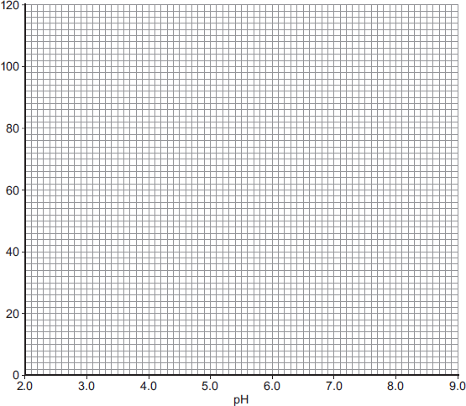
(4)

  - At what pH does the enzyme work best?

........................................

(1)

  - Predict the activity of the enzyme at pH 9.0.

........................................ arbitrary units

(1)

  - Suggest why the enzyme’s activity at pH 3.0 is zero.

...............................................................................................................

...............................................................................................................

(1)
(Total 15 marks)

A group of students investigated the effect of temperature on the action of the enzyme lipase. The students:
4
- put 1 cm 3 of lipase solution into a test tube

- put 5 cm 3 of lipid into a different test tube

- put both tubes in a water bath at 5 °C for 3 minutes

- mixed the lipid with the lipase solution.
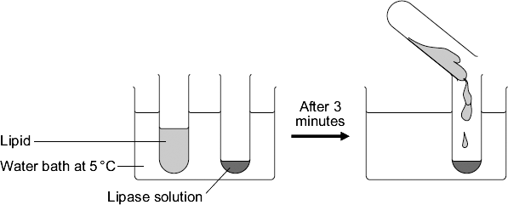

Every five minutes the students tested a sample of the mixture for lipid, until no lipid remained. The students repeated the experiment at different temperatures.

- To make their investigation fair the students needed to control some variables.

Give one variable the students controlled in their investigation.

........................................................................................................................

(1)

- The tubes of lipase solution and lipid were kept separately in the water bath for 3 minutes before mixing. Why?
Tick ( ) one box.

So that the lipase broke down the lipid quickly So that the lipase and the lipid reached the right temperature To give enough time for the lipase to break down the lipid
To give enough time for the water bath to heat up
(1)

The table shows the students’ results.

Temperature in °C | Time taken until no lipid remained in minutes
5 | 40
20 | 15
35 | 5
50 | 30
95 | lipid still there after 120 minutes

- Describe the effect on the breakdown of the lipid of increasing the temperature from 5 °C to 50 °C.

........................................................................................................................

........................................................................................................................

........................................................................................................................

........................................................................................................................

(2)

- Suggest two ways in which the students could have improved their investigation.

Use information from the students’ method and the results table to help you. 1 .....................................................................................................................
........................................................................................................................

........................................................................................................................

2 .....................................................................................................................

........................................................................................................................

........................................................................................................................

(2)

- (i) The lipase did not break down the lipid at 95 °C. Why?
...............................................................................................................

...............................................................................................................

(1)

- At 35 °C the lipase broke down the lipid after 5 minutes.

What new substances will be in the tube? Draw a ring around one answer.

amino acids fatty acids and glycerol sugars

(1)
(Total 8 marks)

The diagram shows a section through a plant leaf.
5
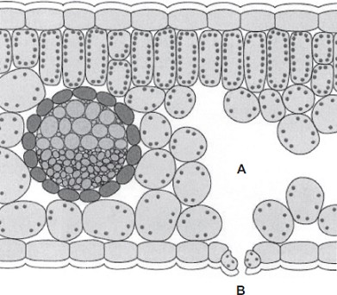

  - Use words from the box to name two tissues in the leaf that transport substances around the plant.
epidermis mesophyll phloem xylem

.................................................................. and ..................................................................

(1)

  - Gases diffuse between the leaf and the surrounding air.

    - What is diffusion?

...............................................................................................................

...............................................................................................................

...............................................................................................................

...............................................................................................................

(2)

    - Name one gas that will diffuse from point A to point B on the diagram on a sunny day.

...............................................................................................................

(1)
(Total 4 marks)

Photosynthesis uses carbon dioxide to make glucose.
6

- (i) Complete the equation for photosynthesis.

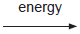
carbon dioxide + .......................... glucose + ....................

(2)

- What type of energy does a plant use in photosynthesis?

...............................................................................................................

(1)

- Which part of a plant cell absorbs the energy needed for photosynthesis?

...............................................................................................................

(1)

- The graph shows the effect of the concentration of carbon dioxide on the rate of photosynthesis in tomato plants at 20 °C.
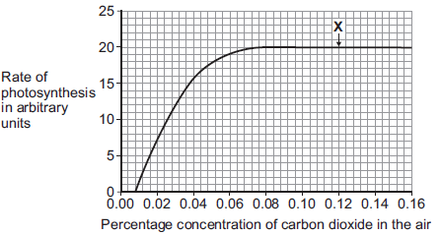

  - What is the maximum rate of photosynthesis of the tomato plants shown in the graph?

.......................... arbitrary units

(1)

  - At point X, carbon dioxide is not a limiting factor of photosynthesis.

Suggest one factor that is limiting the rate of photosynthesis at point X.

...............................................................................................................

(1)

- A farmer plans to grow tomatoes in a large greenhouse.

The concentration of carbon dioxide in the atmosphere is 0.04%.
The farmer adds carbon dioxide to the greenhouse so that its concentration is 0.08%.

  - Why does the farmer use 0.08% carbon dioxide?

Tick ( ) one box.

To increase the rate of growth of the tomato plants To increase the rate of respiration of the tomato
plants

To increase water uptake by the tomato plants
(1)

  - Why does the farmer not use a concentration of carbon dioxide higher than 0.08%?

Tick ( ) two boxes.

Because it would cost more money than using 0.08%
Because it would decrease the temperature of the greenhouse Because it would not increase the rate of photosynthesis of the
tomato plants any further

Because it would increase water loss from the tomato plants
(2)
(Total 9 marks)

    - A student carried out the following investigation using a plant with variegated leaves. A variegated leaf has green and white stripes.
7

The student:

      - left the plant in the dark for 3 days to remove the starch

      - fixed two pieces of card to a leaf on the plant

      - left the plant in the light for 2 days

      - removed the leaf from the plant

      - tested the leaf for starch.

Figure 1 shows how the two pieces of card were attached to the leaf.

Figure 1

Leaf without card Leaf with card

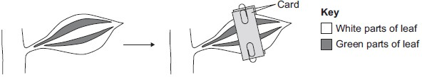

Figure 2 shows the same leaf after 2 days in the light. The leaf has been tested for starch.

Figure 2
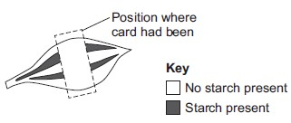
Give two conclusions from this investigation. Tick ) two boxes.
Carbon dioxide is needed for photosynthesis. Chlorophyll is needed for photosynthesis. Light is needed for photosynthesis.
Water is needed for photosynthesis.
(2)

    - Scientists investigated the effect of light intensity on the rate of photosynthesis.

Figure 3 shows the scientists’ results.

Figure 3
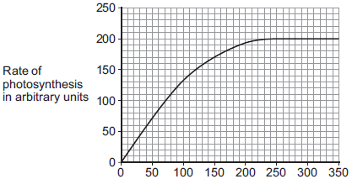
Light intensity in arbitrary units

Describe the effect of increasing light intensity on the rate of photosynthesis. You should include numbers from Figure 3 in your description.

........................................................................................................................

........................................................................................................................

........................................................................................................................

........................................................................................................................

........................................................................................................................

........................................................................................................................

(3)

    - At a light intensity of 250 arbitrary units, light is not a limiting factor of photosynthesis.

- What is the evidence for this in Figure 3?

...............................................................................................................

...............................................................................................................

(1)

- Give two factors that could be limiting the rate of photosynthesis at a light intensity of 250 arbitrary units.

1 ............................................................................................................

2 ............................................................................................................

(2)
(Total 8 marks)

To be healthy, plants need the right amount of mineral ions from the soil. The diagram below shows four plants.
8
The plants were grown in four different growing conditions:

  - sunny area, with nitrate and magnesium added to the soil

  - sunny area, with magnesium but no nitrate added to the soil

  - sunny area, with nitrate but no magnesium added to the soil

  - dark area, with nitrate and magnesium added to the soil.
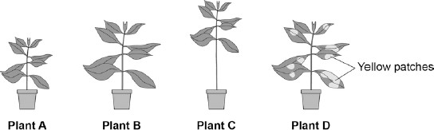

- Which plant was grown with no nitrate?

Tick one box.

A B C D

(1)

- Which plant was grown with no magnesium?

Tick one box.

A B C D

(1)

- Give one variable that was kept constant in this experiment.

........................................................................................................................

........................................................................................................................

(1)

- Plants need other minerals for healthy growth such as potassium ions and phosphate ions.

A farmer wanted to compare the percentage of minerals in two types of manure.

- Cow manure from her own farm.

- Chicken manure pellets she could buy.

The table below shows data for each type of manure.

 | Phosphate ions in % | Potassium ions in %
Cow manure | 0.4 | 0.5
Chicken manure pellets | 2.5 | 2.3

Suggest one advantage and one disadvantage of using the chicken manure pellets compared to the cow manure.

Advantage ......................................................................................................

........................................................................................................................

Disadvantage .................................................................................................

........................................................................................................................

(2)
(Total 5 marks)

A potometer is a piece of apparatus that can be used to measure water uptake by a leafy shoot.
9

Figure 1 shows a potometer.

Figure 1
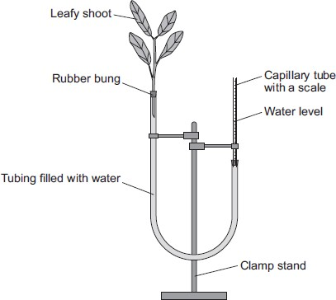

Some students used a potometer like the one shown in Figure 1.

  - They measured the water taken up by a shoot in normal conditions in a classroom.

  - As the water was taken up by the shoot, the level of water in the capillary tube went down.

  - The students recorded the level of the water in the capillary tube at 2-minute intervals for 10 minutes.

Table 1 shows the students’ results.

Table 1

Time in minutes | 0 | 2 | 4 | 6 | 8 | 10
Level of water (on scale) in capillary tube in mm | 2.5 | 3.6 | 4.4 | 5.4 | 6.5 | 7.5

The area of the cross section of the capillary tube was 0.8 mm2.

- (i) Complete the following calculation to find the volume of water taken up by the shoot in mm3 per minute.

Distance water moved along the scale in 10 minutes = ...........mm Volume of water taken up by the shoot in 10 minutes = ..........mm3

Therefore, volume of water taken up by the shoot in 1 minute = ...........mm3

(3)

(ii) The students repeated the investigation but this time placed the potometer next to a fan blowing air over the leafy shoot.

Suggest how the results would be different. Give a reason for your answer.

...............................................................................................................

...............................................................................................................

...............................................................................................................

...............................................................................................................

(2)

- The students repeated the investigation at different temperatures.

The results are shown in Table 2.

Table 2

Temperature in °C | Rate of water uptake in mm3 per minute
10 | 0
15 | 0.4
20 | 1.0
25 | 2.1
30 | 3.2
35 | 4.0
40 | 4.4

Plot the data from Table 2 on the graph paper in Figure 2. Choose suitable scales, label both axes and draw a line of best fit.

Figure 2
(5)

- What would happen to the leaves if the potometer was left for a longer time at 40 °C?

Explain your answer.

........................................................................................................................

........................................................................................................................

........................................................................................................................

........................................................................................................................

........................................................................................................................

........................................................................................................................

(3)
(Total 13 marks)

Mark schemes

  - (aerobic) respiration
1
do not credit anaerobic respiration accept cellular respiration

  - carbon dioxide and water (vapour)
both required
do not credit heat

1

1
[2]

- in yeast:
2
’it’ equals yeast

makes alcohol / makes CO2 / does not make lactic acid
do not allow uses / involves alcohol / CO2
1

- (i) any two from:
allow amount of yeast

  - volume of yeast / suspension

  - volume of sugar / solution
  - concentration of sugar
amount of sugar = max 1 for sugar

  - temperature
(total) volume = 1 mark if no other volume ignore concentration of yeast
2

(ii) most / more CO2 given off with fructose or
’it’ equals fructose

faster CO2 production

or

faster respiration
allow faster fermentation
1

do not allow aerobic respiration

so (rate of) alcohol production will be greatest / more (with fructose)
1

- Marks awarded for this answer will be determined by the Quality of Communication (QC) as well as the standard of the scientific response. Examiners should also refer to the information in the Marking guidance and apply a ‘best-fit’ approach to the marking.
3

0 marks
No relevant content.

Level 1 (1−2 marks)
The method described is weak and could not be used to collect valid results, however does show some understanding of the sequence of an investigation.

Level 2 (3−4 marks)
The method described could be followed and would enable some valid results to be collected, but lacks detail.

Level 3 (5−6 marks)
The method described could be easily followed and would enable valid results to be collected.

Examples of the points made in the response:
  - bean seedlings of same age
  - cut material from same part of each organ (for repeats) e.g. top 1 cm of stem / a whole cotyledon / seed
  - equal mass of each organ
accept weight for mass
  - grind / homogenise
  - in equal amounts of water / buffer
  - equal volumes of hydrogen peroxide solution
  - equal concentrations of hydrogen peroxide solution
  - same temperature
  - temperature maintained in water bath
  - quantitative measure of gas production eg height of foam in mm / collect gas in graduated syringe in cm3
  - for same time period
  - repetitions (3+ times)
  - calculate mean for each.
6

[5]

- (i) correct answer: 40
1 mark for 45 as the anomalous result has been included in the calculation
or

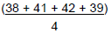
1 mark for

or

- vertical axis correctly labelled: ‘Enzyme activity in arbitrary units’
allow ecf from (b)(i)

points plotted correctly ±1 mm
deduct 1 mark for each incorrect plot

suitable line of best fit
not feathery, not point to point

- 6.0 / 6
allow ± 0.1
if 6.0 not given, allow correct for candidate’s graph ± 0.1

- in range 0 to 14 units
allow correct for candidate’s graph

- enzyme denatured / enzyme (active site) shape changed
allow substrate no longer fits (active site) ignore reference to temperature
do not allow enzyme dies

2

1

2

1

1

1

1
[15]

  - any one from:
4
ignore reference to recording results every 5 minutes or
concentrations of lipid / lipase

    - (same) volume / amount / 1 cm 3 lipase
allow amount of solution

    - (same) volume / amount / 5 cm 3 lipid
allow keep same volumes in the test tubes

    - mixed after 3 minutes / same time before mixing
do not accept temperature
1

  - so that the lipase and the lipid reached the right temperature
1

  - any two from
ignore explanations

    - decrease in time or faster (breakdown)

    - then increase in time or then slower (breakdown)

    - fastest / least time / optimum at 35°C
2

  - any two from:
ignore ‘test at more temperatures’ unqualified

    - test more regularly eg test every minute
any interval < 5min

    - test at smaller temperature intervals
any value <15°C
allow test more temperatures in the range

    - test between 50 (°C) and 95 (°C)
any value in range, eg test at 70

    - repeat at same temperatures
or repeat the investigation
or compare results with others
allow do it again
2

  - (i) (lipase / it) denatured / destroyed / changed shape
allow damaged / deformed do not accept killed
ignore broken (down)

(ii) fatty acids and glycerol

1
[8]

- xylem and phloem
5
either order
allow words ringed in box
allow mis-spelling if unambiguous

- (i) movement / spreading out of particles / molecules / ions / atoms
ignore names of substances / ‘gases’

from high to low concentration
accept down concentration gradient ignore ‘along’ / ‘across’ gradient ignore ‘with’ gradient

(ii) oxygen / water (vapour)
allow O2 / O2
ignore O2/ O allow H2O / H2O
ignore H2O

(a) (i) LHS = water
6
accept H2O
do not accept H2O / H2O

RHS = oxygen
accept O2
do not accept O / O2 / O2

- light / sunlight
ignore solar / sun / sunshine do not allow thermal / heat

- chloroplasts
allow chlorophyll

1

1

1

1
[4]

1

1

1

1

(b) (i) 20

- any one from:
  - light (intensity)
  - temperature.

(c) (i) To increase the rate of growth of the tomato plants

(ii) Because it would cost more money than using 0.08%

Because it would not increase the rate of photosynthesis of the tomato plants any further

- chlorophyll is needed for photosynthesis
7

light is needed for photosynthesis

- increases

levels off / reaches a maximum / remains constant / stays the same / plateaus
do not allow stops / stationary / peaks allow stops increasing

goes up to / reaches a maximum / levels off at (a rate of) 200 (arbitrary units)

or
levels off at 225 – 240 (light units)
ignore references to other numerical values

- (i) higher light intensity does not increase rate of photosynthesis
accept the graph stays level (above this value) allow stops increasing
allow the rate of photosynthesis stays the same (above this value)

1

1

1

1

1
[9]

1

1

1

1

1

1

(ii) any two from:

A
8

- D
- carbon dioxide (concentration)
- temperature / heat
- (amount of) chlorophyll / chloroplasts
allow water
allow ions / nutrients
ignore ref to surface area of the leaf

2
[8]

1

1

- use the same type of plant

or
give equal amount of water to each plant
ignore size of pot

- (advantage) more minerals

(disadvantage) cost / not free

(a) (i) 5.0
9

(5 × 0.8) or 4
allow ecf from distance

1

1

1
[5]

1

1

0.4
allow ecf from 10-min volume
1

(ii) increased (rate of uptake)
1

more transpiration / evaporation
1

- correct scales
allow reversed axes
1

correctly labelled axes with units
1

correct points
one plot error = max 1 mark
2

curved line of best fit
allow correct straight line
1

- leaves wilt

because plants lose too much water (by evaporation)

through the stomata

or
because cells become plamolysed

or
stomata close controlled by guard cells to prevent wilting

1

1

1
[13]

